Minha Tassadduq
ICT Birthday Picture Assignment

My Original Picture
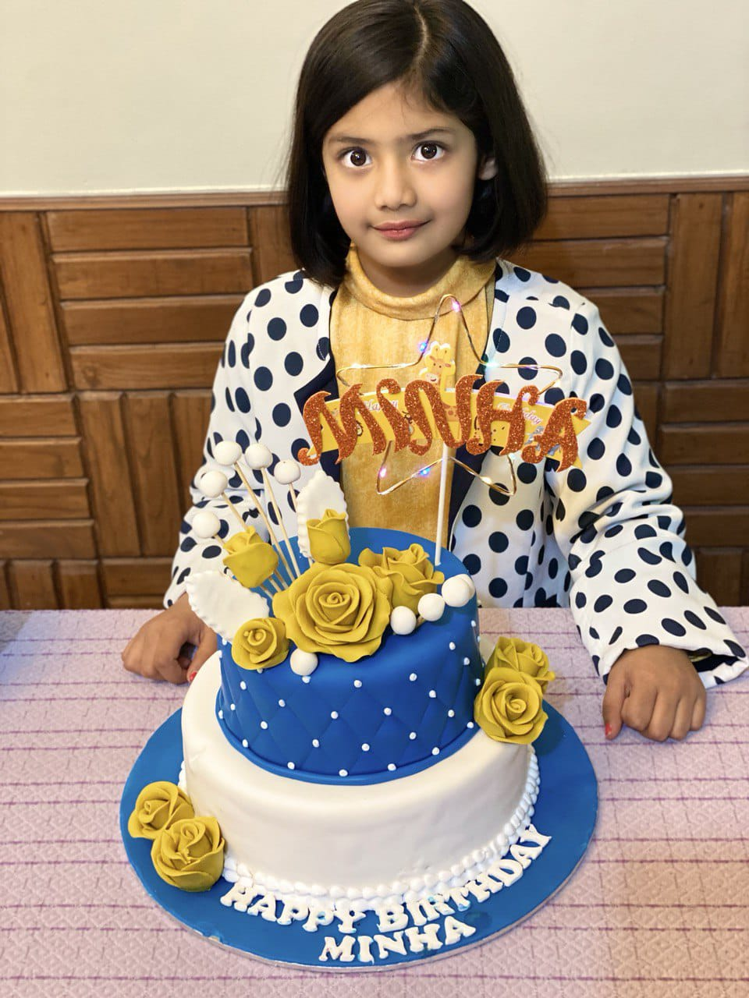
Contrast enhancement:
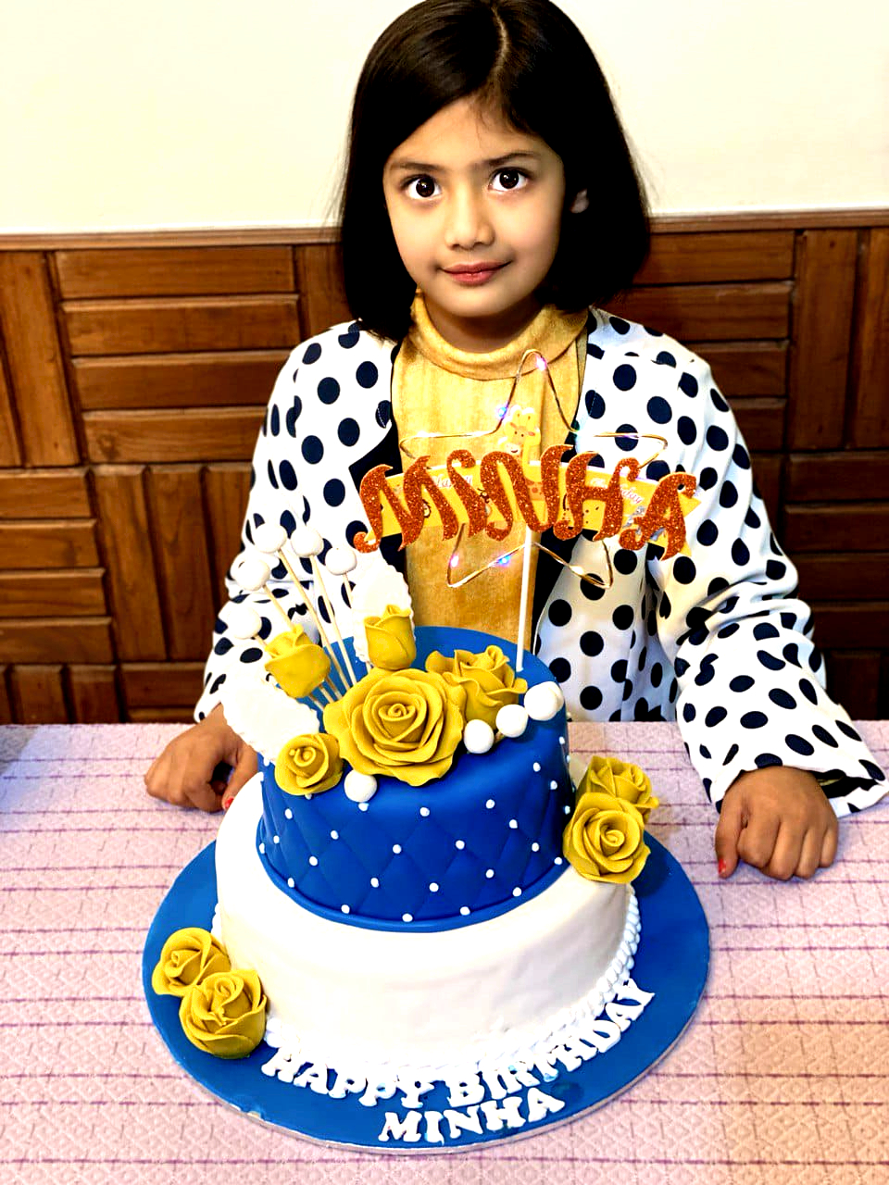

Sharpen enhancement:
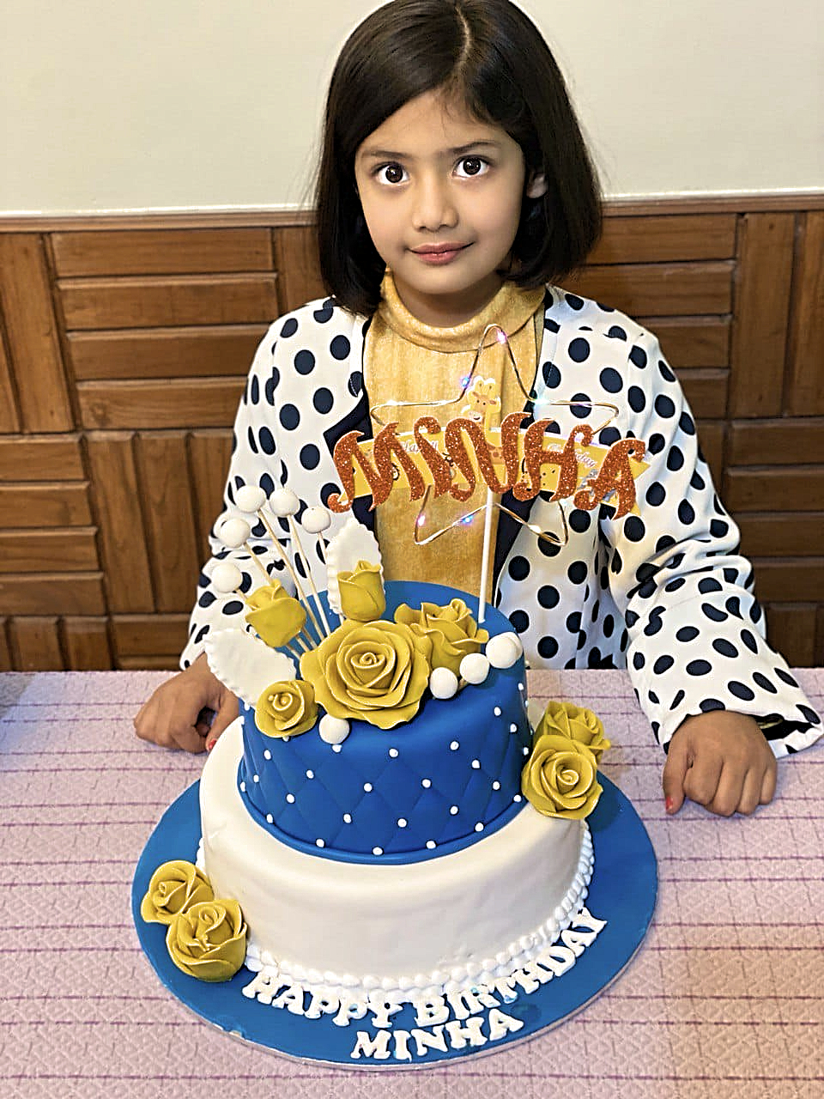

Blue enhancement:
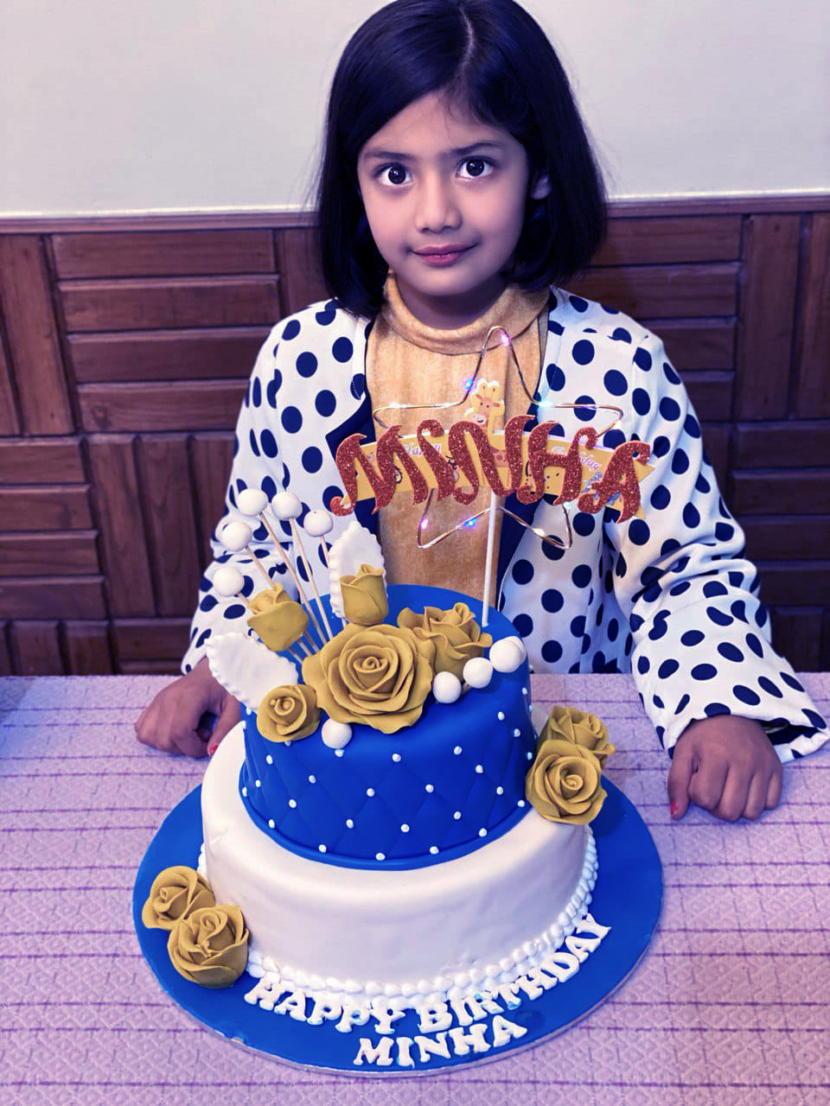

Sound Effects :
- Whoosh Sound
- Party Whistle
- Short Crowd Cheering
- Fireworks
- Party Popper

